**Experiment No : 1**

Name : Patil Rajashri Jaywant

**Title : Create Table And Apply Some Queries.**

**1.Show All Databases :**

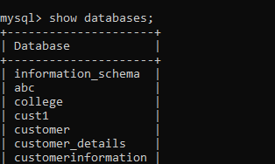

**2. Create Databases :**

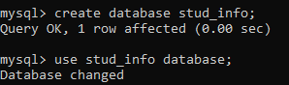

**3.Create Table :**

* 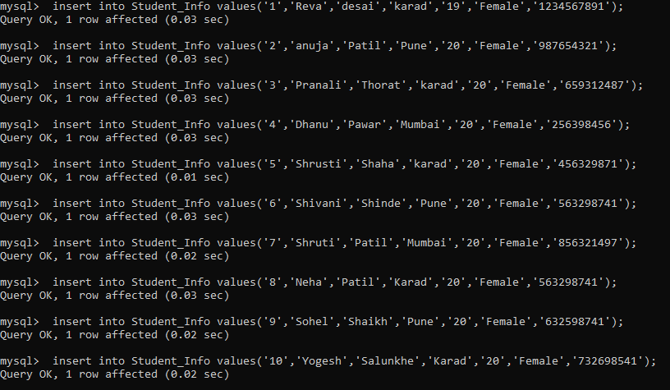 **Inserting :**
* **Select :**

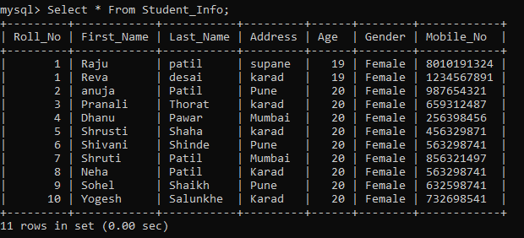

**4.Update :**

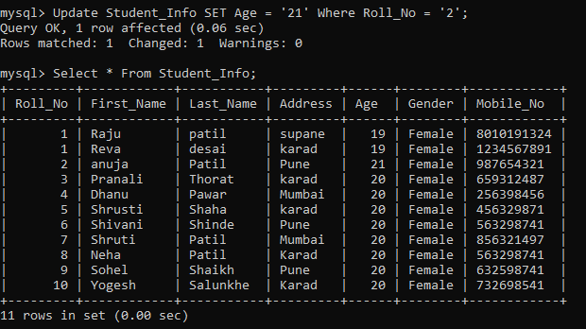

**5. Delete :**

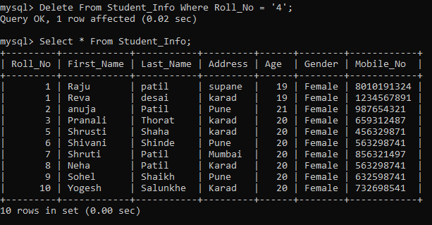

**6. Alter Table :**

**A] Add :**

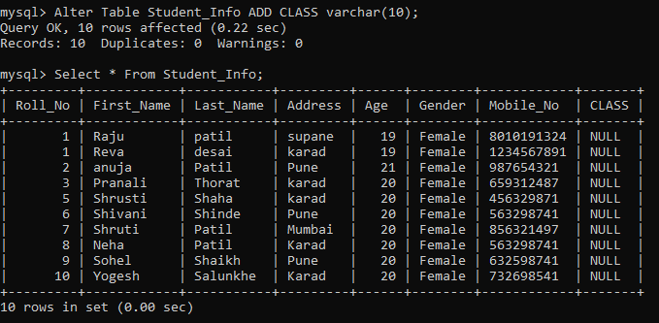

**B] Drop :**

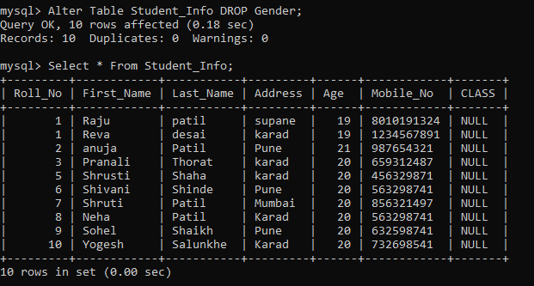

**C] Modify :**

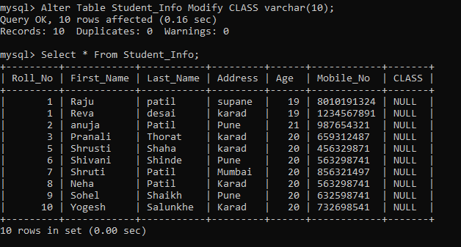

**7.Renaming :**

**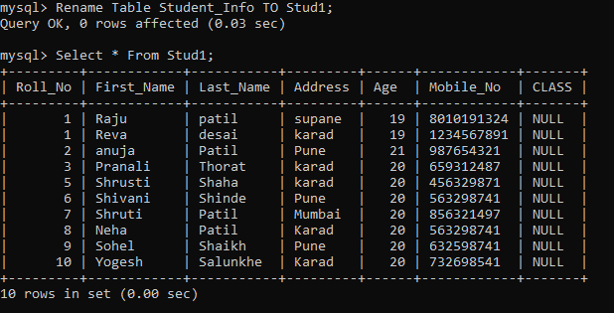  
8. Truncate :**

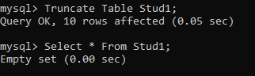

**9. Drop Table :**

